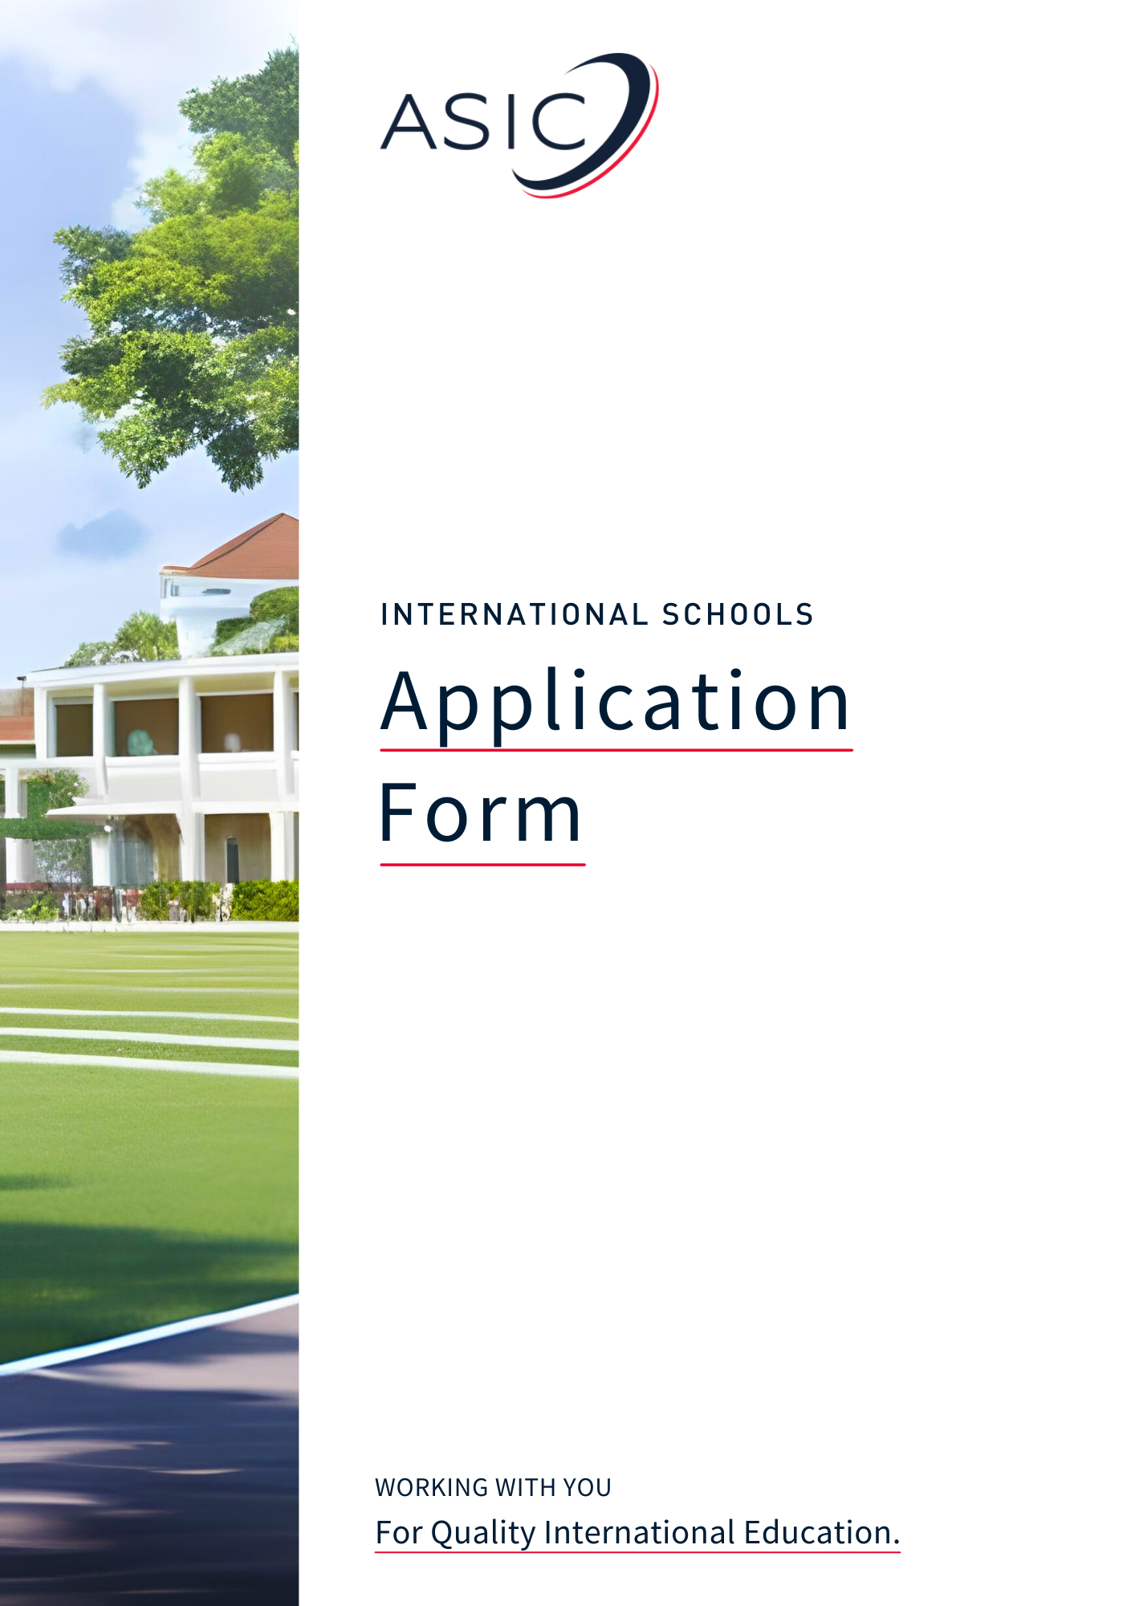

Applying to ASIC for Accreditation
Thank you for your interest in applying for ASIC Accreditation and welcome to the start of the process.

We are aware that the array of documents that we need to see and even the application form itself can, at first sight, appear daunting. Differences in terminology can be confusing, or you may find items which are not relevant to your type of school. So, before you begin, we have explained the process and provided guidance notes, all designed to help you fill out the form easily and quickly.

Please read the guidance notes before starting to complete your application. We hope you find them helpful.

Explanation of the Application Process

- Please complete the Application Form, using the accompanying guidance notes, and send this to ASIC with the Application Fee* of £1,000. Note, at this stage no other documentation is required. Please ensure that you have read the Accreditation Handbook and understand your institution's responsibilities in holding ASIC Accreditation, including the payment of fees and the requirement to abide by the ASIC Code of Conduct and Ethics.

- On its receipt, the Application Form will be checked by one of our assessors. ASIC will then send you the Stage 1 Self-Evaluation Form and make a request to the institution for the Stage 1 documents, please see below titled “CHECKLIST OF DOCUMENTS TO BE SENT AT STAGE 1.” (These documents are required to be sent to ASIC before any inspection visit takes place and this includes institutions applying for Candidacy Accreditation and Interim Accreditation.)

- ASIC will then contact the institution to either discuss the Stage 1 documentation further, or to organise the Stage 2 inspection.

* Please be aware that the Accreditation Team will be unable to process your application until our Finance Department has confirmed receipt of the Application Fee.

Guidance notes for completing the form

Filling out the application form:

- First and foremost, the completion of the Application Form and Checklist is intended as a way of gathering all the necessary information required for Stage 1, it is not a ‘test’ to ascertain whether a School should be considered for accreditation. If you require any clarification or advice when completing the form, the ASIC Office team are always happy to help. Please e-mail your query to info@asic.org.uk or call us on +44 (0)1740 617920.

- The Application Form follows the Stages within an inspection visit, looking at the Areas of Operation in sequence. You may find it helpful to cross-reference with the Accreditation Handbook and the ASIC Standards of Accreditation (specific to your type of institution) for fuller information.

- We suggest that you keep a copy of the Application Form, as you will find it an invaluable route through the inspection visit(s); its completion takes care of a very large part of your preparation for Stage 2.

- The questions on the Application Form cover schools of varying size. Small, specialist schools should not be deterred by references to facilities or services that they cannot realistically offer and may fill in N/A (not applicable) where appropriate. We will contact you for more information where this is needed.

- You will probably find that several questions/document requests are not relevant to your institution. Where this is the case, please insert N/A. If we require an explanation, we will let you know. For example: some schools do not prepare food on their premises; many do not offer awards other than their own; some do not use agents; some are not required to engage with the immigration authorities in their country.

- As you complete the form you will notice there are shaded guidance boxes throughout, use the notes in these boxes to ensure you correctly input the information required for that section. In some sections we have also provided notes further explaining what will need to be seen during the Stage 2 Inspection.

Documentation:

- Please do not be deterred by the number of documents required as per the Checklist. You will find that most, if not all, will already exist - with the great majority being essential for the legal operation of your institution, and accreditation/approval by authorised bodies in your own country. Many of the documents (those which are relevant to your School) may be held by more than one section of your administration, some may need updating, and only a few may need to be obtained for the first time. You will find this a beneficial opportunity to collate them all into one place.

- Most schools have found collating the documents to be a useful exercise, not only for gaining ASIC Accreditation but also for future endeavours. The resulting compendium is in a format and sequence that is likely to be required by schools in another country, or any professional body, with whom you wish to form a partnership, thus helping to facilitate setting up future relationships of this kind.

- Quite a few documents mentioned in the Application Form/Checklist, e.g. Disability Strategy or Equal Opportunities Policy, may be embedded in information your School covers in its Pupil Handbook/Staff Handbook/Prospectus/Quality Manual. Where information is already available in this way, simply refer us to its location rather than produce documents specially.

Terminology:

- ASIC uses the term ‘staff’ to refer to all employees of a School, including teaching, administrative, technical, and all other support workers.

You are now ready to begin completing the Application Form.

If you have any questions before you start, please e-mail info@asic.org.uk or ring +44 (0)1740 617920.

(The ASIC Office is open UK office hours Monday to Friday, except for Bank Holidays, 09:00-17:00.)

We hope you will find the accreditation process useful and productive. We look forward to working with you.

Application Form

Please note:

In places where you are unsure what to put/whether to fill in N/A, please do not hesitate to ask us before you submit your application.

We suggest that you fill out the form as best you can, noting any questions you may have along the way, then send any/all of your questions regarding the application in one e-mail to info@asic.org.uk.

This speeds up the process considerably and ensures that you submit the information required first time round. Completing the application as efficiently as you are able means your School will progress straight through to the Inspection Stage as quickly as is possible.

SCHOOL DETAILS

School Name:

N.B. Please state ALL places of operation and
Indicate which of these are to be accredited.

Details of operation(s) and those to be accredited:
Head of School (Name & Title e.g., Professor, Dr):
Address:

Postcode:
Telephone number:
Website address:

Email of Head of School:

Name & email of Point of Contact for all correspondence* from ASIC regarding the accreditation process:

*This contact will be automatically signed up to the ASIC Members Newsletter where information about ASIC Members offers, events, and member resources from ASIC and our partners is circulated.

Name & Email of Finance Manager/Account Manager:

Addresses of any other places the School operates:

Address of administrative headquarters (if different from above):

Where did you hear about ASIC e.g. recommendation, web search, website, social media platform?

This field is optional: Please enter any additional email addresses of all those who would like to receive the ASIC Newsletter (to hear about ASIC news, events, and promotional opportunities for your institution) in the box below. On receipt of the application, we will add the email addresses provided to our mailing list. Please keep an eye on your inbox for the double opt-in email to confirm that you are happy to receive the Newsletter.

LEGAL STATUS AND FINANCIAL DETAILS

Date of formation of the School:

Provide details and dates of any recent (last 5 years) major re-structuring, e.g. change of ownership, change of School name, change of premises:

Please state whether the School is publicly or privately owned:

N.B. The question below regards the legal status of the School (e.g. as a limited
company or a charity) and lists positions which may be involved its governance.
If any/all of these do not apply to your School, please enter N/A as appropriate.

If you have stated the School is private company, please list the names of the following positions:
Owners:
Directors:
Officers:
Governors:
Trustees:

Is the School a subsidiary company of another organisation? (Indicate Yes as Y or No as N.)

If yes, state full name, legal status, and country in which organisation was founded/incorporated:

Is the School a Limited Company? (Y/N) If yes, state if limited by shares or by guarantee:

If yes, provide the following information:
Company name:
Registration no: Date of registration:

If no, please state the terms on which the business operates:
Documents authenticating the legal status of the School must be available for inspection: if a Charity,
the Registration number; if a Limited Company, the Certificate of Incorporation; if a Partnership, the Partnership Agreement; if a subsidiary company, documentation applicable to then legal status of parent organisation.

Name & address of the School bankers:

Name & address of the School accountants:

A) GOVERNANCE, MANAGEMENT, AND STAFF RESOURCES

STAFF

Head of School’s full name and title of post (e.g., Principle, Head Teacher):

Qualifications:

Number of years in post:

State the numbers of staff in the following categories:
Teaching Full-time:
Permanent part-time:
Temporary/Occasional part-time:
Teaching Assistants:

Support staff Administrative:
Support Staff (e.g., Cleaners/Lunchtime Supervisors):

PUPILS

Indicate the numbers of pupils attending the School in each of the previous and current years:
Full-time (according to local regulations) Previous: Current:

Number of international pupils and pupils of Ex Patriot families (current year only):
International: Ex Patriot:

COPYRIGHT AND DATA PROTECTION
N.B. Copyright compliance can be via self-regulated
arrangements where there is no statutory system.

Do you adhere to local and international copyright regulations? (Y/N)

Do you adhere to international data protection protocols? (Y/N)

C) SYSTEMS MANAGEMENT

TRACKING & MONITORING OF LOCAL PUPILS

What systems (paper/electronic) are in place to track pupil attendance and measure cumulative attendance?

What mechanisms do you have for contacting pupils/parents/guardians about their absence?

TRACKING & MONITORING OF INTERNATIONAL PUPILS

What systems (paper/electronic) are in place to track pupil attendance and measure cumulative attendance?

What mechanisms do you have for contacting pupils/parents/guardians about their absence?

How do you track applicants who have applied for visas then fail to enrol “no shows” (if this a requirement in your country)?

If the following are required in your country, please describe your procedures for informing the immigration authorities of no shows, pupils whose attendance falls below local statutory limits, and pupils not progressing through their course within the maximum timescale allowed.

Where applicable, documents relating to immigration reporting requirements will be inspected during inspection visit and may include the following:

- Sample letters to pupils about their absence.
- Sample letters to the immigration authorities about no shows, unsatisfactory attendance, and unsatisfactory progress.

D) LEARNING, TEACHING; COURSE DELIVERY

ACADEMIC PROGRESS

Please state the ways in which you monitor & record pupils’ progress:

Do you monitor pupil completion rates? (Y/N)

Do you have a staff development policy? (Y/N)

E) AWARDS AND QUALIFICATIONS

ACADEMIC PROGRAMME

Please list ALL courses/programmes, together with the awarding body, currently running at the School:

F) PUPIL WELFARE, BEHAVIOUR AND PERSONAL DEVELOPMENT

SERVICES AND RESOURCES

Please identify services provided for pupils and whether they are included within overall fees (Y/N):
Accommodation Provided: Included in Fees:
Recommended textbooks Provided: Included in Fees:
Teaching materials Provided: Included in Fees:
Internet access/e-mail Provided: Included in Fees:
Printing facilities Provided: Included in Fees:
School Uniform Provided: Included in Fees:
Writing/drawing materials Provided: Included in Fees:
Musical Instruments Provided: Included in Fees:
Other (please specify here) Provided: Included in Fees:

Do you issue pre-arrival guidance to pupils about living on campus (if applicable)? (Y/N)

Do you have a no tolerance policy on Bullying and Harassment? (Y/N)

Who monitors this?

Do you have an anti-racism policy? (Y/N)

Who monitors this?

PUPILS UNDER 18 YEARS

Current number of pupils under the age of 18:

Describe the accommodation arrangements for these pupils (if applicable):

Do you have a Child Protection Policy? (Y/N) If Y, please state who monitors this.

State the number of staff police checked or equivalent (if applicable):

SPECIAL EDUCATIONAL NEEDS AND DISABILITY

Do you have a have a Special Educational Needs and Disability (SEND) policy? (Y/N)

Are there staff responsible for children with Special Educational Needs and Disabilities (Y/N)

G) PREMISES, AND HEALTH AND SAFETY

PREMISES

Are the premises owned or leased by the School?

If leased, please give expiry date(s) for the lease:
Please note: The lease agreement(s) must be available for inspection at Stage 2.

Please give details of teaching accommodation (incl. number and approximate capacity of classrooms project rooms, drama and music suites, laboratories/facilities, computer suites, practice rooms, library, common rooms, counselling rooms and any other specific classrooms) etc:

Give details of resources and equipment to support teaching (e.g., LCD projectors, IT equipment, interactive whiteboards, practice-related equipment, research resources etc):

Provide details of resources available to pupils for independent study and project preparation (either in the School or elsewhere). Please also state any link with local libraries and/or online library support provided:

List examples of social/sporting facilities provided (e.g., common rooms, access to sporting facilities):

Please give details of any play or soft play areas (inside or outside):

HEALTH AND SAFETY

If food is prepared on the premises, do you have a certificate from a relevant local body showing compliance with health/sanitary regulations? (In some countries this may not be applicable.) (Y/N)

Name of the person responsible for Health and Safety:

Number of staff trained as first-aiders:

N.B. Employer’s Liability Insurance is a UK provision taken out by employers to protect
employees in the workplace. Some countries have a similar system, others provide a national
scheme. Some schools have developed their own voluntary scheme. In some countries
relevant insurance simply does not exist. Please indicate which situation applies to your School.

Have you Employer’s Liability Insurance or equivalent?

Please ensure that you complete and enclose the following from the Appendices to the Application:

- Appendix 3: Health and Safety declaration.
- Appendix 4: Fire Precautions declaration.

Please detail your schools’ security arrangements (including the receiving/collecting of pupils):

Do you have a school lockdown policy and procedure? (Y/N)

Do you have a dedicated security manager? (Y/N)

How many security staff are employed?

H) MARKETING AND RECRUITMENT OF PUPILS

MARKETING

Name and contact details of Marketing Officer:

N.B. In relation to the question below, the Ethics Policy should
be the text which primarily relates to pupil recruitment.

Do you have an Ethics Policy? (Y/N)

Do you use recruitment agents? (Y/N)

Do your agents/staff receive marketing training? (Y/N)

Please note: your website will be critically assessed during the Stage 1 process.

State when your prospectus and website were last updated:

SELECTION AND ADMISSION

How does the School initially assess pupils’ English Language and study skills (if appropriate)?

Please state provision (if any) made for teaching English as a second/foreign language. Is this provision accredited, and, if so, by whom?

Checklist of Documents to be seen at Stage 2

The checklist details documents which need to be sent to ASIC to help complete the Stage 1 process. Please mark the boxes with an “X” to show which documents you have available. If you find that any of the documents are not applicable to your institution, please insert N/A (we will advise you if we find otherwise).
N.B. If you have completed a self-study for your national accreditation or accreditation with another organisation, then the documents below may be contained within the study. If so, please attach the
self-study to this document and signpost the relevant page number in the boxes below.

1. | Copy of the latest 3 years audited annual Accounts
A) GOVERNANCE, MANAGEMENT, AND STAFF RESOURCES
2. | Diagram of staffing structure
3. | List of names and designations of all staff
4. | CVs of all management and academic/senior administrative staff
5. | Staff appointment procedures
6. | Sample staff contract
7. | Equal Opportunities Policy
8. | Staff Handbook
9. | Procedures for recording pupils’ attendance
10. | Procedures for the conduct of examinations/tests
11. | Procedures for the production of examination/test papers
12. | Arrangements for secure storage of examination papers/scripts
D) LEARNING, TEACHING, AND COURSE DELIVERY
13. | Pupil application form
14. | Pre-enrolment information for pupils detailing course entry requirements, fees payable, documents to be presented at enrolment
15. | Pupil Handbook/Sample Course Handbook
E) AWARDS AND QUALIFICATIONS
16. | Appendix 2 completed for each course running  (One sample per level, e.g. bachelors, masters, doctorates)
17. | Guidance on academic misconduct
F) PUPIL WELFARE
18. | Pre-arrival information for pupils regarding living on campus
G) PREMISES AND HEALTH & SAFETY
19. | Sketch of floor plans
20. | Health & Safety Declaration, Appendix 3
21. | Fire Precautions Declaration, Appendix 4, and a Fire Risk Assessment*
H) MARKETING AND RECRUITMENT OF PUPILS
22. | Ethics Policy
23. | Criteria for the appointment of marketing agents
24. | Marketing Agent’s agreement
25. | Briefing documents for marketing agents
26. | Prospectus (if applicable)
27. | Procedures for processing enquiries and applications
28. | Procedures relating to pupil admissions and enrolment
29. | Procedures for monitoring pupil records
30. | Procedures for the handling of deposits, fee payments and refunds

*The Fire Risk Assessment should be conducted by a competent external agency such as the local fire service. Where this is not an option, a thorough report conducted by the School’s own health and safety office can be used as a viable alternative.

References

Please give the name, position, and contact details of two people willing to support the School’s application for accreditation. At least one should also be able to provide a personal reference for the Head of the School.

Person 1:

Person 2:

Appendix 1

DECLARATION BY HEAD OF SCHOOL

Declaration: To be made by the Head of the School

- I declare that to the best of my knowledge the School, of which I am the Head, is financially stable and able to meet its commitments in terms of both staff salaries and advertised study programmes.

- I declare that the information provided in this application is correct and all supporting documents are genuine and accurate.

- I have taken reasonable steps to confirm the accuracy of the claims made by staff in respect of qualifications and experience.

- I am prepared to accept the final decision of ASIC as to the outcome of the inspection.

- I agree to indemnify ASIC against all claims, demands, expenses and complaints arising from inaccuracies in the information given by me above.

- I authorise ASIC to approach the School’s bankers (as shown on page 5) and the two people I have nominated as referees to gain information relating to this application, on the understanding that this information will be treated in absolute confidence.

- I agree to inform ASIC of any changes in the ownership of the School or senior management, or significant variation in the academic programme, which occur more than three months before the scheduled date for submitting the annual report.

- I accept that the term "Accredited by the Accreditation Service for International Schools, Colleges & Schools" means that my School has been inspected by ASIC and found to be satisfactory, and I undertake not to represent my School as enjoying this recognition before it has been granted nor after it has been withdrawn or suspended.

- I understand that failure to continue compliance with the accreditation criteria may lead to the removal of my School’s accreditation by ASIC.

- I have read the UK Accreditation Handbook (Section 3.2) and understand my institution's responsibilities in holding ASIC Accreditation, including the payment of fees and the requirement to abide by the ASIC Code of Ethics. I understand that failure to continue compliance may lead to the removal of my Institution’s accreditation by ASIC.

Signed: Date:

Name: Position:

For and on behalf of (name of School):

Appendix 2

COURSE DETAILS
Please note: A separate sheet should be completed for each course. (We are asking for the information below to help provide us with initial insight into the structure of the courses on offer at the School. More comprehensive information will be sought during the Stage 2 Inspection.)

Programme title:

Entry qualifications:

Maximum number in class:

Average class contact hours per week:

Examining body:

Academic level:

Certificate awarded, and by whom:

Duration of course:

Teacher/Course Leader responsible for the course:

Brief outline of the course content and its delivery:

Appendix 3

HEALTH AND SAFETY DECLARATION

Declaration to be completed to comply with health and safety requirements:

I confirm that the School satisfies the basic requirements for Schools in relation to health and safety, namely:

- A risk assessment has been carried out, which has identified any areas of harm and precautions to be taken.

- A health and safety policy exists for the School.

- The School has any relevant current employer’s liability insurance on display.

- Named staff have received health and safety training.

- The School receives competent advice to assist in meeting health and safety requirements.

- Basic health, safety and welfare needs of staff and pupils are met: i.e. toilets, washing facilities, drinking water are provided on the premises.

- Staff are consulted on health and safety issues.

- Relevant health and safety instructions are prominently displayed.

- There is a facility for reporting work-related accidents, diseases, and dangerous occurrences.

Signed (Head of School or Owner): Date:

Name: Position:

Name of School:

Addresses of premises to which this declaration applies:

Appendix 4

FIRE PRECAUTIONS DECLARATION

Declaration to be completed:

- I certify that the premises identified below comply with local statutory requirements and that a fire risk assessment has been undertaken by a competent external agency.

- I am satisfied that adequate steps have been taken to ensure that:

  - The means of escape with which the premises are provided are safe and efficient and that escape routes are unobstructed and clearly signposted.

  - Fire detection equipment, fire extinguishers, fire alarms and emergency lighting within the premises are maintained in efficient working order.

  - All employees and pupils receive instructions on what to do in the event of fire.

  - Fire drills are held at appropriate intervals and that these are recorded.

- I am satisfied that there is a minimal risk of danger from fire to the pupils and staff in my care and I understand any legal repercussions/criminal prosecution that I may face if I do not provide the means of escape or the means for fighting fires.

Signed (Head of School or Owner): Date:

Name: Position:

Name of School:

Addresses of premises to which this declaration applies:

