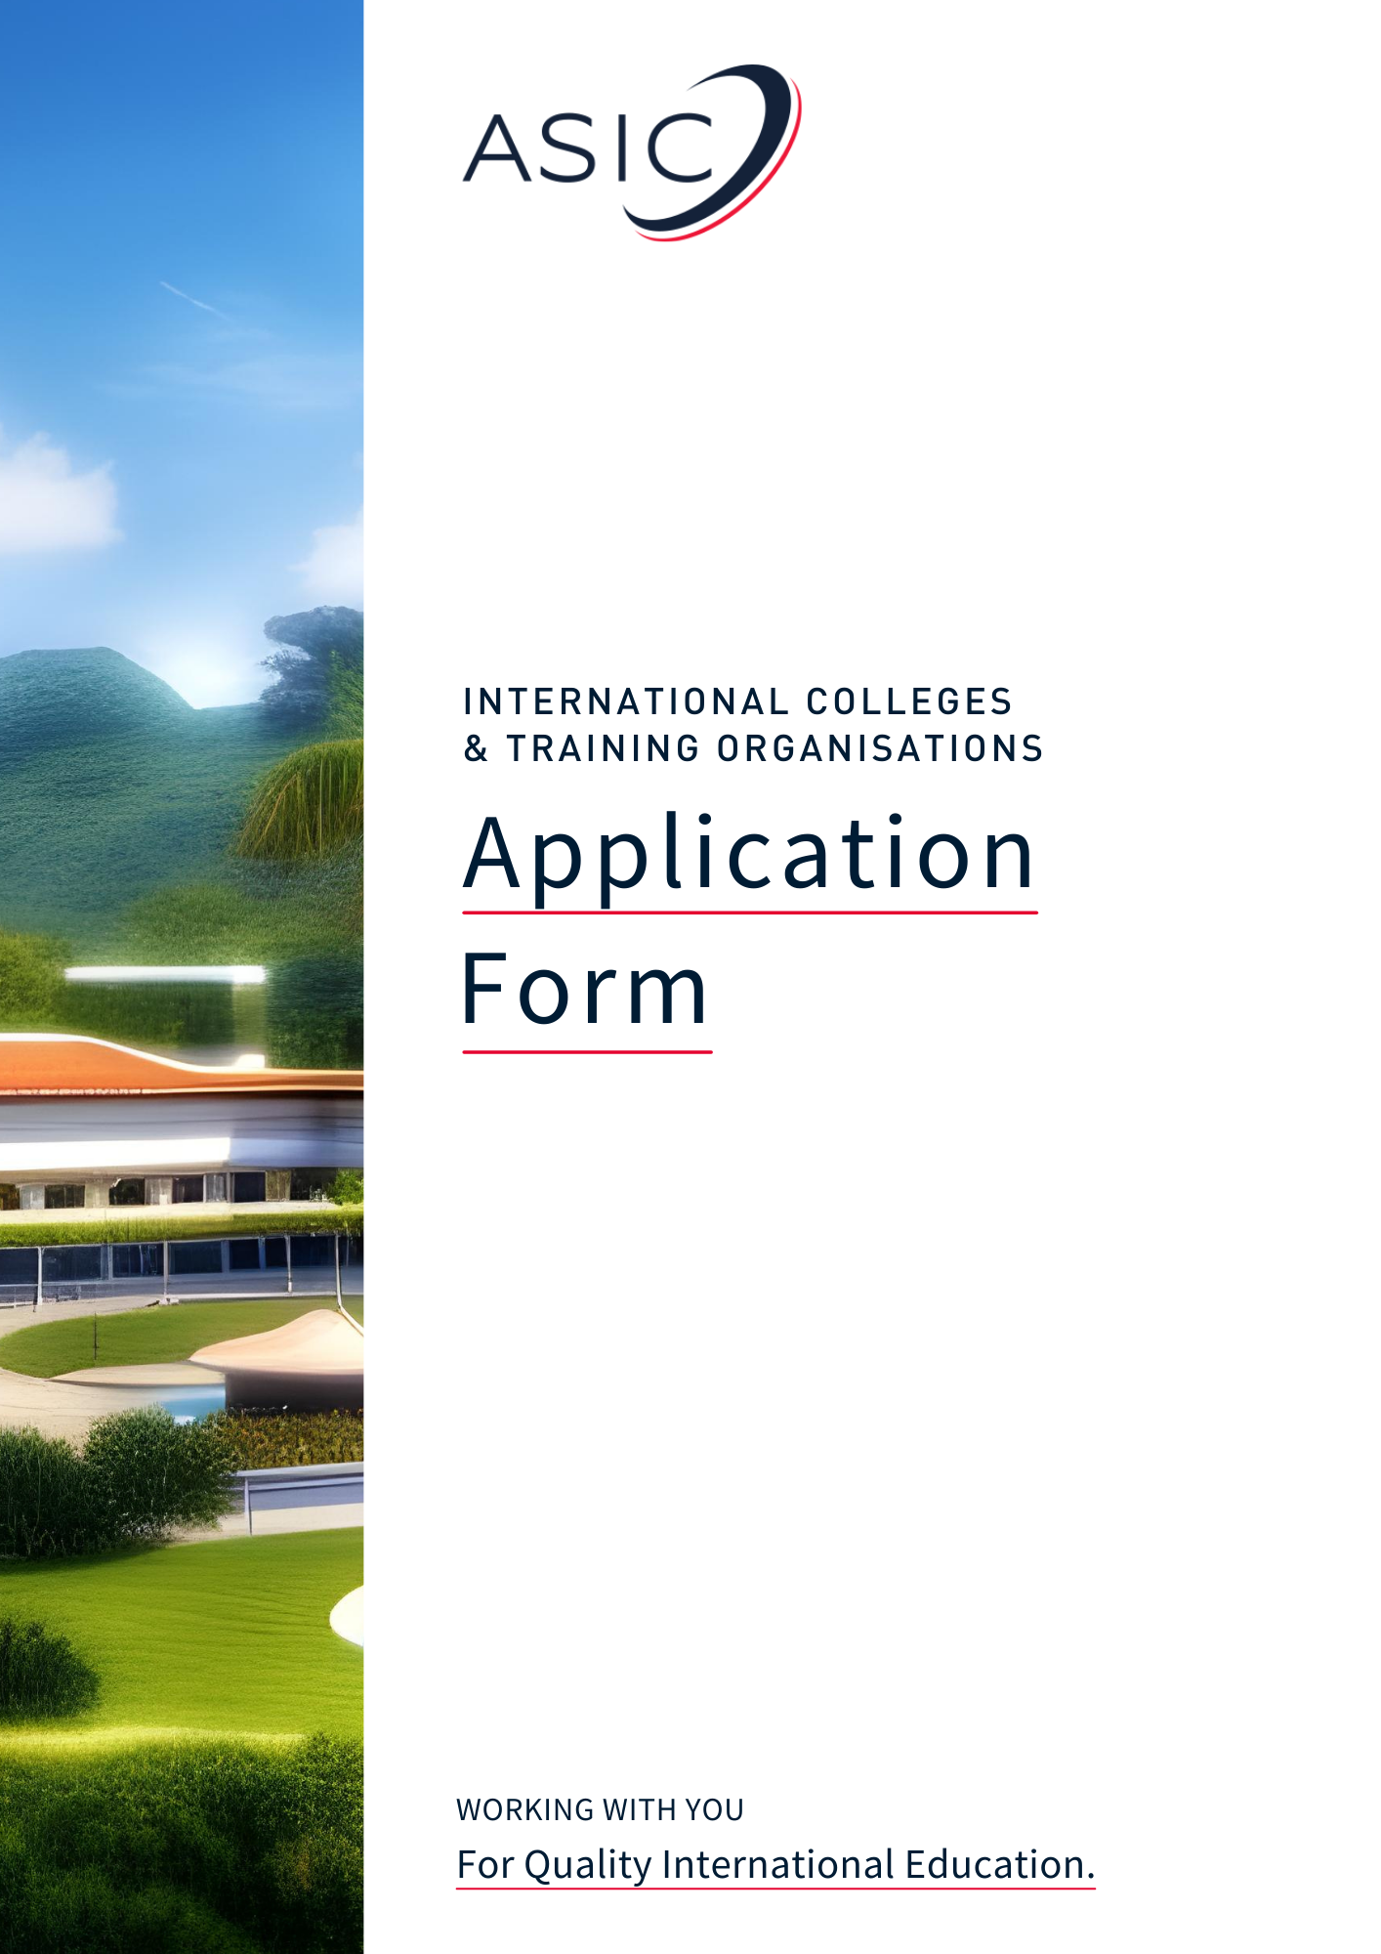

Applying to ASIC for Accreditation
Thank you for your interest in applying for ASIC Accreditation and welcome to the start of the process.

We are aware that the array of documents that we need to see and even the application form itself can, at first sight, appear daunting. Differences in terminology can be confusing, or you may find items which are not relevant to your type of institution. So, before you begin, we have explained the process and provided guidance notes, all designed to help you fill out the form easily and quickly.

Please read the guidance notes before starting to complete your application. We hope you find them helpful.

Explanation of the Application Process

- Please complete the Application Form, using the accompanying guidance notes, and send this to ASIC with the Application Fee* of £1,000. Note, at this stage no other documentation is required. Please ensure that you have read the Accreditation Handbook and understand your institution's responsibilities in holding ASIC Accreditation, including the payment of fees and the requirement to abide by the ASIC Code of Conduct and Ethics.

- On its receipt, the Application Form will be checked by one of our assessors. ASIC will then make a request to the institution for the Stage 1 documents, please see below titled “CHECKLIST OF DOCUMENTS TO BE SENT AT STAGE 1.” (These documents are required to be sent to ASIC before any inspection visit takes place and this includes institutions going for Candidacy Accreditation and Interim Accreditation.)

- ASIC will then contact the Institution to either discuss the Stage 1 documentation, or to organise the Stage 2 inspection.

* Please be aware that our Accreditation Team will be unable to process your application until our Finance Department has confirmed receipt of the Application Fee.

Guidance notes for completing the form
Filling out the application form:

- First and foremost, the completion of the Application Form and Checklist is intended as a way of gathering all the necessary information required for Stage 1, it is not a ‘test’ to ascertain whether an institution should be considered for accreditation. If you require any clarification or advice when completing the form, the ASIC Office team are always happy to help. Please e-mail your query to info@asic.org.uk or call us on +44 (0)1740 617920.

- The Application Form follows the Stages within an inspection visit, looking at the Areas of Operation in sequence. You may find it helpful to cross-reference with the Accreditation Handbook and the ASIC Standards of Accreditation (specific to your type of institution) for fuller information.

- We suggest that you keep a copy of the Application Form, as you will find it an invaluable route through the inspection visit(s); its completion takes care of a very large part of your preparation for the inspection stage.

- The questions on the Application Form cover institutions of varying size. Small, specialist institutions should not be deterred by references to facilities or services that they cannot realistically offer and may fill in N/A (not applicable) where appropriate.

- You will probably find that several questions/document requests are not relevant to your institution. Where this is the case, please insert N/A. If we require an explanation, we will let you know. For example: some institutions do not prepare food on their premises; some do not have students aged under 18; many do not offer awards other than their own; some do not use agents; some are not required to engage with the immigration authorities in their country.

- As you complete the form you will notice there are shaded guidance boxes throughout, use the notes in these boxes to ensure you correctly input the information required for that section. In some sections we have also provided notes further explaining what will need to be seen during the Stage 2 inspection.

Documentation:

- Please do not be deterred by the number of documents required as per the Checklist. You will find that most, if not all, will already exist with the great majority being essential for the legal operation of your institution, and accreditation/approval by authorised bodies in your own country. Many of the documents (those which are relevant to your Institution) may be held by more than one section of your administration, some may need updating, and only a few may need to be obtained for the first time. You will find this a beneficial opportunity to collate them all into one place.

- Most institutions have found collating the documents to be a useful exercise, not only for gaining ASIC Accreditation but also for future endeavours. The resulting compendium is in a format and sequence that is likely to be required by institutions in another country, or any professional body, with whom you wish to form a partnership, thus helping to facilitate setting up future relationships of this kind.

- Quite a few documents mentioned in the Application Form/Checklist, e.g. Disability Strategy or Equal Opportunities Policy, may be embedded in information your Institution covers in its Student Handbook/Staff Handbook/Prospectus/Quality Manual. Where information is already available in this way, simply refer us to its location rather than produce documents specially.

Terminology:

There are a couple of terms which can cause confusion.

- ASIC uses the term ‘Programme’ to refer to the entire sequence of study leading to an award. Thus, BA Business Studies is a Programme lasting three or four years. We use the term ‘Course’ to refer to one discrete part of a Programme. A Course typically lasts one semester or sometimes one academic year. For example: ‘Year One, Introduction to Marketing’, is a one-semester Course forming part of the three or four-year BA Business Studies Programme. Courses are also known as Modules and Units (all three terms are used concurrently in the UK).

- ASIC uses the term ‘staff’ to refer to all employees of a Institution, including teaching academics, internship/work placement staff, and researchers as well as administrative, technical, and other support workers.

You are now ready to begin completing the Application Form.

If you have any questions before you start, please e-mail info@asic.org.uk or ring +44 (0)1740 617920. (The ASIC Office is open UK office hours Monday to Friday, except for Bank Holidays, 09:00-17:00.)

We hope you will find the accreditation process useful and productive. We look forward to working with you.
Application Form

Please note:

In places where you are unsure what to put/whether to fill in N/A, please do not hesitate to ask us before you submit your application.

We suggest that you fill out the form as best you can, noting any questions you may have along the way, then send any/all of your questions regarding the application in one e-mail to info@asic.org.uk.

This speeds up the process considerably and ensures that you submit the information required first time round. Completing the application as efficiently as you are able means your School will progress straight through to the Inspection Stage as quickly as is possible.

INSTITUTION DETAILS

Institution Name:

N.B. State ALL places of operation and
indicate which of these are to be accredited.

Head of Institution (Name & Title e.g., Professor, Dr):
Address:

Postcode:
Telephone number:
Website address:
Details of operation(s) to be accredited:

Email of Head of Institution:

Name & email of Point of Contact for all correspondence* from ASIC regarding the accreditation process:

*This contact will be automatically signed up to the ASIC Members Newsletter where information about ASIC Members offers, events, and member resources from ASIC and our partners is circulated.

Name & Email Address of Finance Manager/Account Manager:

Addresses of any other places the Institution operates:

Address of administrative headquarters (if different from above):

Where did you hear about ASIC e.g., recommendation, web search, website, social media platform?

This field is optional: Please enter any additional email addresses of all those who would like to receive the ASIC Newsletter (to hear about ASIC news, events, and promotional opportunities for your institution) in the box below. On receipt of the application, we will add the email addresses provided to our mailing list. Please keep an eye on your inbox for the double opt-in email to confirm that you are happy to receive the Newsletter.

LEGAL STATUS AND FINANCIAL DETAILS

Date of formation of the Institution:

Provide details and dates of any recent (last 5 years) major re-structuring, e.g., change of ownership, change of Institution name, change of premises:

Please state whether the Institution is publicly or privately owned:

N.B. The question below regards the legal status of the Institution (e.g., as a limited
company or a charity) and lists positions which may be involved its governance.
If any/all of these do not apply to your Institution, please enter N/A as appropriate.

If you have stated the Institution is private company, please list the names of the following positions:
Owners:
Directors:
Officers:
Governors:
Trustees:

Is the Institution a subsidiary company of another organisation? (Indicate Yes as Y or No as N.)

If yes, state full name, legal status, and country in which organisation was founded/incorporated:

Is the Institution a Limited Company? (Y/N) If yes, state if limited by shares or by guarantee:

If yes, provide the following information:
Company name:
Registration no: Date of registration:

If no, please state the terms on which the business operates:
Documents authenticating the legal status of the Institution must be available for inspection: if a Charity, the Registration number; if a Limited Company, the Certificate of Incorporation; if a Partnership, the Partnership Agreement; if a subsidiary company, documentation applicable to the legal status of parent organisation.

Name & address of the Institution bankers:

Name & address of the Institution accountants:

A) GOVERNANCE, MANAGEMENT, AND STAFF RESOURCES

STAFF

Head of Institution’s name and title of post (e.g., President, Vice Chancellor, CEO):

Qualifications:

Number of years in post:

State the numbers of staff in the following categories:
Teaching/Internship/Work Placement staff: Full-time:
Permanent part-time:
Temporary/Occasional part-time:

Support staff: Administrative:
Technical:

STUDENTS
Indicate the numbers of students attending the Institution in each of the previous and current years:
Full-time (according to local regulations) Previous: Current:

Part-time (according to local regulations) Previous: Current:

Number of international and local students (current year only):
International: Local:

COPYRIGHT AND DATA PROTECTION
N.B. Copyright compliance can be via self-regulated
arrangements where there is no statutory system.

Do you adhere to local and international copyright regulations? (Y/N)

Do you have protocols and systems in place to protect data relating to your employees and students (in some countries a registration certificate is also required)? (Y/N)

C) SYSTEMS MANAGEMENT

TRACKING & MONITORING OF LOCAL STUDENTS

What systems (paper-based and/or electronic) do you have in place to track student attendance and measure cumulative attendance?

What mechanisms do you have for contacting students about their absence?

TRACKING & MONITORING OF INTERNATIONAL STUDENTS

What systems (paper-based and/or electronic) do you have in place to track student attendance and measure cumulative attendance?

What mechanisms do you have for contacting students about their absence?

How do you track applicants who have applied for visas then fail to enrol “no shows” (if this a requirement in your country)?

If the following are required in your country, please describe your procedures for informing the immigration authorities of no shows, students whose attendance falls below local statutory limits, and students not progressing through their course within the maximum timescale allowed.

Where applicable, documents relating to immigration reporting requirements will be inspected during inspection visit and may include the following:

- Sample letters to students about their absence.
- Sample letters to the immigration authorities about no shows, unsatisfactory attendance,
and unsatisfactory progress.

D) LEARNING, TEACHING AND RESEARCH ACTIVITY
ACADEMIC PROGRESS

Please state the ways in which you monitor & record students’ progress (incl. research students)?

Do you monitor student completion rates? (Y/N)

Do you have a staff development policy? (Y/N)

E) AWARDS AND QUALIFICATIONS

ACADEMIC PROGRAMME

Please list ALL programmes currently running at the Institution; state if they include internship/WP activity.

Programmes leading to the Institution’s own awards:

If you offer degree programmes, do you have degree awarding powers for your own awards? Y/N
N.B. Most institutions only award their own degrees, but some also offer programmes leading to the awards
of other bodies (e.g., in the UK, many institutions prepare students for the awards of professional bodies in
Accountancy and in Law). This is why we have listed the other categories, again please enter N/A as appropriate.

Programmes leading to awards of other awarding bodies e.g., City and Guilds of London Institute:

Programmes leading to awards of professional bodies:

Programmes leading to awards of overseas organisations:

Main areas of internship/WP activity; how is this monitored and assessed?

F) PUPIL WELFARE, BEHAVIOUR AND PERSONAL DEVELOPMENT

SERVICES AND RESOURCES

Please identify services provided for students and whether they are included within overall fees (Y/N):
Accommodation Provided: Included in Fees:
Recommended textbooks Provided: Included in Fees:
Teaching materials Provided: Included in Fees:
Internet access/e-mail Provided: Included in Fees:
Printing facilities Provided: Included in Fees:
Internship/WP documentation Provided: Included in Fees:
Others (please specify here) Provided: Included in Fees:

Do you issue pre-arrival guidance to students about living on campus? (Y/N)

STUDENTS UNDER 18 YEARS
N.B. Some institutions do not have students aged under 18.
Where that is the case, simply enter N/A, throughout this section.

Current number of students under the age of 18:

Describe the accommodation arrangements for these students:

Do you have a Child Protection Policy (if applicable)? (Y/N)

State the number of staff police checked (if applicable):

SPECIAL EDUCATIONAL NEEDS AND DISABILTY

Do you have a Disability Strategy? (Y/N)

G) PREMISES, AND HEALTH AND SAFETY

PREMISES

Are the premises owned or leased by the Institution?

If leased, please give expiry date(s) for the lease:

Please note: The lease agreement(s) must be available for inspection at Stage 2.

Please give details of teaching accommodation (incl. number and approximate capacity of classrooms, internship/work placement (WP) centres, computer suites, practice rooms), library, student common rooms, counselling rooms etc:

Give details of resources and equipment to support teaching (e.g., LCD projectors, IT equipment, interactive whiteboards, practice-related equipment, internship/WP resources etc):

Please provide details of resources available to students for independent study (either in the Institution or elsewhere). Please state any link, such as access for your students to local libraries (e.g., major national libraries/libraries of other institutions) incl. online library support:

List examples of social/sporting facilities provided (e.g., common rooms, access to sporting facilities):

HEALTH AND SAFETY

If food is prepared on the premises, do you have a certificate from a relevant local body showing compliance with health/sanitary regulations? (In some countries this may not be applicable) (Y/N)

Name of the person responsible for health and safety:

Number of staff trained as first-aiders:

N.B. Employer’s Liability Insurance is a UK provision taken out by employers to protect
employees in the workplace. Some countries have a similar system, others provide a national
scheme. Some institutions have developed their own voluntary scheme. In some countries
relevant insurance simply does not exist. Please indicate which situation applies to your Institution.

Have you Employer’s Liability Insurance or equivalent (in some countries this may be voluntary)?

Please ensure that you complete and enclose the following from the Appendices to the Application:

- Appendix 3: Health and Safety declaration.
- Appendix 4: Fire Precautions declaration.

H) MARKETING AND RECRUITMENT OF PUPILS

MARKETING

Name and contact details of Marketing Officer:

N.B. In relation to the question below, the Ethics Policy should
be the text which primarily relates to student recruitment.

Do you have an Ethics Policy? (Y/N)

Do you have student recruitment agents? (Y/N)

Do your agents/staff receive training on promoting the Institution? (Y/N)

Please note: your website will be critically assessed during the Stage 1 process.

State when your prospectus and website were last updated:

SELECTION AND ADMISSION

How does the Institution initially assess students’ English Language and study skills (if appropriate)?

Please state provision (if any) made for teaching English as a second/foreign language. Is this provision accredited, and, if so, by whom?

Checklist of Documents to be seen at Stage 2
The checklist details documents which may need to be sent to ASIC to help complete the Stage 1 process. Please mark the boxes with an “X” to show which documents you have available. If you find any of the documents are not applicable to your institution, please insert N/A (we will advise you if we find otherwise).
N.B. If you have completed a self-study for your national accreditation or accreditation with another organisation, then the documents below may be contained within the study. If so, please attach the
self-study to this document and signpost the relevant page number in the boxes below.

1.a. | License to operate as an Education Institution
1.b. | Copy of the latest 3 years audited annual Accounts
A) GOVERNANCE, MANAGEMENT, AND STAFF RESOURCES
2. | Diagram of staffing structure
3. | List of names and designations of all staff
4. | CVs of management, academic, internship/WP tutors, and senior administrative staff
5. | Staff appointment procedures
6. | Sample staff contract
7. | Equal Opportunities Policy
8. | Staff Handbook
9. | Procedures for recording students’ attendance
10. | Procedures for the conduct of examinations/tests
11. | Procedures for the production of examination/test papers
12. | Arrangements for secure storage of examination papers/scripts
D) LEARNING, TEACHING, AND INTERNSHIP/ WORK PLACEMENT ACTIVITY
13. | Student application form
14. | Pre-enrolment information for students detailing course entry requirements, fees payable, documents to be presented at enrolment
15. | Student Handbook/Sample Course Handbook
E) AWARDS AND QUALIFICATIONS
16. | Sample descriptions of academic/vocational programmes, see Appendix 2.  (One sample per level, e.g. bachelors, masters, doctorates)
17. | Guidance on academic misconduct
F) STUDENT WELFARE
18. | Pre-arrival information for students regarding living on campus
G) PREMISES AND HEALTH & SAFETY
19. | Sketch of floor plans
20. | Health & Safety Declaration, Appendix 3
21. | Fire Precautions Declaration, Appendix 4, and a Fire Risk Assessment*
H) MARKETING AND RECRUITMENT OF STUDENTS
22. | Ethics Policy
23. | Criteria for the appointment of marketing agents
24. | Marketing Agent’s agreement
25. | Briefing documents for marketing agents
26. | Prospectus
27. | Procedures for processing enquiries and applications
28. | Procedures relating to student admissions and enrolment
29. | Procedures for monitoring student records
30. | Procedures for the handling of deposits, fee payments and refunds

*The Fire Risk Assessment should be conducted by a competent external agency such as the local fire service. Where this is not an option, a thorough report conducted by the Institution’s own Health and Safety Office can be used as a viable alternative.

References

Please give the names, position, and contact details of two people willing to write in support of the Institution’s application for accreditation.
Person 1:

Person 2:

Appendix 1

DECLARATION BY HEAD OF UNIVERSITY

Declaration: To be made by the Head of the Institution

- I declare that to the best of my knowledge the Institution, of which I am the Head, is financially stable and able to meet its commitments in terms of both staff salaries and advertised study programmes.

- I declare that the information provided in this application is correct and all supporting documents are genuine and accurate.

- I have taken reasonable steps to confirm the accuracy of the claims made by staff in respect of qualifications and experience.

- I am prepared to accept the final decision of ASIC as to the outcome of the inspection.

- I agree to indemnify ASIC against all claims, demands, expenses and complaints arising from inaccuracies in the information given by me above.

- I authorise ASIC to approach the Institution’s bankers (as shown on page 5) and the two people I have nominated as referees (as shown on page 12) to gain information relating to this application, on the understanding that this information will be treated in absolute confidence.

- I agree to inform ASIC of any changes in the ownership of the Institution or senior management, or significant variation in the academic programme, which occur more than three months before the scheduled date for submitting the annual report.

- I accept that the term "Accredited by the Accreditation Service for International Schools, Colleges & Institutions" means that my Institution has been inspected by ASIC and found to be satisfactory, and I undertake not to represent my Institution as enjoying this recognition before it has been granted nor after it has been withdrawn or suspended.

- I understand that failure to continue compliance with the accreditation criteria may lead to the removal of my Institution’s accreditation by ASIC.

- I have read the International Accreditation Handbook (Section 3.2) and understand my institution's responsibilities in holding ASIC Accreditation, including the payment of fees and the requirement to abide by the ASIC Code of Ethics. I understand that failure to continue compliance may lead to the removal of my Institution’s accreditation by ASIC.

Signed: Date:

Name: Position:

For and on behalf of (name of Institution):

Appendix 2

COURSE DETAILS

Please supply one sample per level, e.g. Certificate, Diploma, Advanced Diploma and Degree.

Please note: the sample programme details are intended to give ASIC an initial insight into the typical structure of your programmes. More comprehensive information will be sought during the inspection.

Programme title:

Entry qualifications:

Maximum number in class:

Average class contact hours per week:

Examining body:

Academic level:

Certificate awarded, and by whom:

Duration of programme:

Programme Leader responsible for the course:

Brief outline of the programme content and its delivery:

Appendix 3

HEALTH AND SAFETY DECLARATION

Declaration to be completed to comply with health and safety requirements:

I confirm that the Institution satisfies the basic requirements typically placed upon employers regarding health and safety, namely:

- A risk assessment has been carried out, which has identified any areas of harm and precautions to be taken.

- A health and safety policy exists for the Institution.

- The Institution has any relevant current employer’s liability insurance on display.

- Named staff have received health and safety training.

- The institution receives competent advice to assist in meeting health and safety requirements.

- Basic health, safety and welfare needs of staff and students are met: i.e. toilets, washing facilities, drinking water are provided on the premises.

- Staff are consulted on health and safety issues.

- Relevant health and safety instructions are prominently displayed.

- There is a facility for reporting work-related accidents, diseases, and dangerous occurrences.

Signed (Head of Institution or Owner): Date:

Name: Position:

Name of Institution:

Addresses of premises to which this declaration applies:

Appendix 4

FIRE PRECAUTIONS DECLARATION

Declaration to be completed:

- I certify that the premises identified below comply with local statutory requirements and that a fire risk assessment has been undertaken by a competent external agency.

- I am satisfied that adequate steps have been taken to ensure that:

  - The means of escape with which the premises are provided are safe and efficient and that escape routes are unobstructed and clearly signposted.

  - Fire detection equipment, fire extinguishers, fire alarms and emergency lighting within the premises are maintained in efficient working order.

  - All employees and students receive instructions on what to do in the event of fire.

  - Fire drills are held at appropriate intervals and that these are recorded.

- I am satisfied that there is a minimal risk of danger from fire to the students and staff in my care.

Signed (Head of Institution or Owner): Date:

Name: Position:

Name of Institution:

Addresses of premises to which this declaration applies:

